How to manage your inhaler stock at home
Did you know you don’t have to order your inhalers every month if you have enough stock at home?
So, what do you need to do?
- Check your stock before you order more. It’s always best to have two of each inhaler available (one in use and another one as a spare).

The inhalers will stay on your repeat prescription even if you do not reorder them. Any changes to your repeat prescription will be discussed with you, by your doctor or other health care professional.

- If you have more than one inhaler on your repeat prescription, it is common to have these inhalers running low at different times due to the differences in how often you use them.

- Check your inhaler dose counter (only available on certain inhalers) that will change to red when there are "20" doses left, this will help you manage your repeat prescription ordering.

- Don’t waste your inhalers by spraying a test dose. To check the inhaler is not empty, shake the canister or look at the dose counter.

- Please tell your pharmacy that you have enough inhalers if your pharmacy orders your prescription every month on your behalf. This is to save them reordering unnecessary inhalers for you next time.

If you use other methods of ordering your repeat prescription, for example, online, via the NHS app or a prescription ordering direct service, please check your stock at home before reordering.

- Check your prescription bag before you leave the pharmacy and return any unwanted inhalers, whilst still inside the pharmacy. Once inhalers have left the pharmacy, they cannot be used for someone else. If you have your prescription delivered, check your prescription bag before the delivery driver leaves and hand any unwanted inhalers back to them.

- Ensure that you go for regular asthma or COPD reviews at your GP practice to check you are using your inhalers correctly.

- Your doctor, nurse or practice pharmacist may adjust your inhaler quantities on your prescription to suit your treatment. This can change over time and this should be reviewed regularly.
Recycling empty containers
Once your inhaler is empty, the container can be recycled at some local pharmacies. Used aerosol canisters still contain propellants that are powerful greenhouse gases and can contribute to global warming. All used aerosol canisters should be returned to a pharmacy to dispose of in an environmentally safe way. Note that spacers cannot currently be recycled - please dispose of these safely.
Please use this as a guide to see how long your inhalers should last and when you would need to reorder:
Number of doses per inhaler  (Refer to the table overleaf) | Number of doses per day  (You will find the doses per day on your pharmacy label on the inhaler) | How often ONE inhaler would need reordering | Tick your dose
200 | One inhalation twice a day | Every 3-4 months
200 | Two inhalations once a day | Every 3-4 months
200 | Two inhalations twice a day | Every 50 days (6-7 weeks)
200 | Two inhalations three times a day | Every 33 days (4 weeks)
200 | One inhalation four times a day | Every 50 days (6-7 weeks)
120 | Two inhalations once a day | Every 60 days (8 weeks)
120 | One inhalation twice a day | Every 60 days (8 weeks)
120 | Two inhalations twice a day | Every 30 days (4 weeks)
100 | One inhalation twice a day | Every 50 days (6-7 weeks)
100 | Two inhalations twice a day | 25 days (1 inhaler every 3 weeks or order 2 inhalers every 6 weeks)
100 | Two inhalations once a day | Every 50 days (6-7 weeks)
60 | One inhalation twice a day | Every 30 days (4 weeks)
60 | One inhalation once a day | Every 60 days (8 weeks)
60 | Two inhalations twice a day | 15 days (1 inhaler every 2 weeks or order 2 inhalers every 4 weeks)
60 | Two inhalations once a day | Every 30 days (4 weeks)
30 | One inhalation once a day | Every 30 days (4 weeks)

- If your inhalers are to be inhaled when required, then these inhalers will normally last you longer. It’s always best to have two of each of these inhalers available (one in use and another one as a spare). When you finish the one in use and start on the spare inhaler, then you know it’s time to reorder an additional inhaler.

- If there are no directions on how to use your inhaler on the pharmacy label, please speak to your pharmacy or GP practice for advice.

- If your dose is not in the above table – please speak to your pharmacy about how long your inhalers should last before you need to reorder more.

How many doses does my inhaler contain? (circle yours)
Salbutamol  Airomir®, Airsalb®,  Salamol®, Ventolin® MDI (aerosol)  200 | Easyhaler® Salbutamol  (dry powder)  200 | Salamol® Easi-Breathe® CFC free salbutamol (aerosol)  200 | Airomir® Autohaler® salbutamol (aerosol)  200 | Ventolin® Accuhaler® salbutamol  (dry powder)  60 | Bricanyl® Turbohaler®  terbutaline  (dry powder)  100 | Salbulin® Novolizer®  salbutamol  (dry powder cartridges)  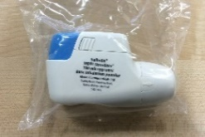  200
Atimos® Modulite® formoterol MDI (aerosol)  100 | Easyhaler® Formoterol  (dry powder)  120 | Foradil®  formoterol  (dry powder capsules)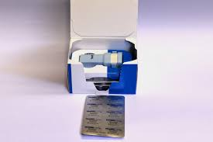  60 | Neovent® CFC free salmeterol MDI  (aerosol)  120 | Onbrez® Breezhaler® indacaterol  (inhalation powder, hard capsule)  30 | Oxis® Turbohaler® formoterol  (dry powder)  60 | Serevent® Accuhaler® salmeterol  (dry powder)  60
Soltel® CFC free  salmeterol MDI  (aerosol)  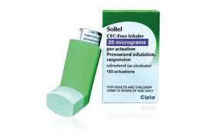  120 | Serevent® Evohaler®  salmeterol MDI  (aerosol)  120 | Striverdi® Respimat® olodaterol (solution for inhalation)  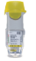  60 | Spiriva® HandiHaler® tiotropium (inhalation powder, hard capsule)  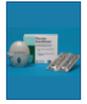  30 | Eklira® Genuair® aclidinium  (dry powder)  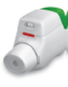  60 | Incruse® Ellipta® umeclidinium  (dry powder)  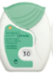  30 | Seebri® Breezhaler® glycopyrronium  (dry powder)  30
Spiriva® Respimat® tiotropium MDI  (aerosol)  60 | Atrovent®  ipratropium MDI  (aerosol)  200 | Clenil® Modulite® beclometasone MDI (aerosol)  200 | Easyhaler® Beclometasone  (dry powder)  200 | Qvar® beclometasone MDI (aerosol)  200 | Qvar® Easi-Breathe® beclometasone MDI (aerosol)  200 | Qvar® Autohaler® beclometasone breath actuated MDI (aerosol)  200
Easyhaler® Budesonide  (dry powder)  100mcg & 200mcg - 200  400mcg - 100 | Flixotide® Accuhaler® fluticasone propionate  (dry powder)  60 | Flixotide® Evohaler® fluticasone propionate MDI  (aerosol)  120 | Pulmicort® Turbohaler® budesonide  (dry powder)  100mcg - 200  200mcg -100  400mcg - 50 | Budelin® Novolizer® budesonide  (dry powder cartridge)  100 | Duaklir® Genuair® formoterol & aclidinium  (dry powder)  60 | Anoro® Ellipta® vilanterol & umeclidinium  (dry powder)  30
Spiolto® Respimat® tiotropium & olodaterol MDI  (solution for inhalation)  60 | Ultibro® Breezhaler® glycopyrronium & indacaterol  (inhalation powder, hard capsule)  60 | Fostair® beclometasone & formoterol MDI  (aerosol)  120 | Fostair® NEXThaler® beclometasone & formoterol  (dry powder)  120 | DuoResp® Spiromax®  budesonide & formoterol  (dry powder)  160/4.5 - 120  320/9 - 60 | Symbicort® Turbohaler® budesonide & formoterol  (dry powder)  100/6 & 200/6 -120  400/12 - 60 | AirFluSal® Forspiro® fluticasone propionate & salmeterol  (dry powder)  60
Flutiform®  fluticasone propionate & formoterol MDI (aerosol)  120 | Relvar® Ellipta® fluticasone furoate & vilanterol  (dry powder)  30 | Seretide® Accuhaler®  fluticasone propionate & salmeterol  (dry powder)  60 | Seretide® Evohaler®  fluticasone propionate & salmeterol MDI (aerosol)  120 | Sirdupla®  fluticasone propionate & salmeterol MDI (aerosol)  120 | Symbicort® budesonide & formoterol MDI  (aerosol)  80/4.5 - 60  160/4.5 - 120 | AirFluSal® fluticasone propionate  & salmeterol MDI (aerosol)  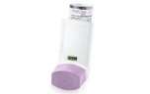  25/125 - 120  25/250 - 120
AirFluSal® Forspiro® fluticasone propionate  & salmeterol  (dry powder)  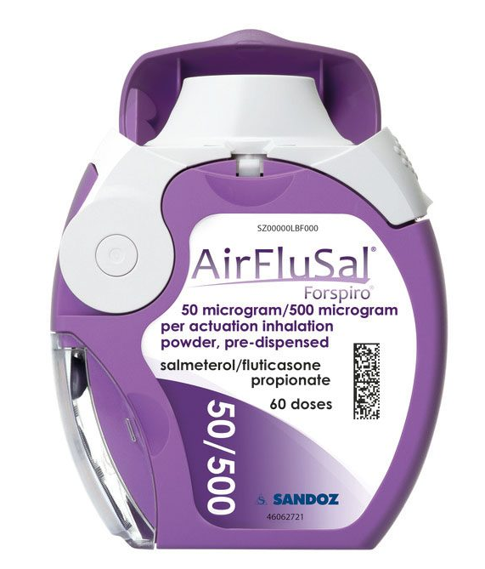  120 | Aerivio® Spiromax® fluticasone propionate  & salmeterol  (dry powder)  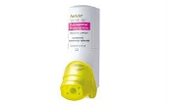  60 | Trimbow® beclometasone, formoterol & glycopyrronium MDI  (aerosol)  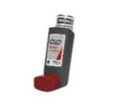  120 | Trelegy® Ellipta®  fluticasone furoate, vilanterol & umeclidinium (dry powder)  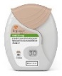  30

